Question 1

* 1. 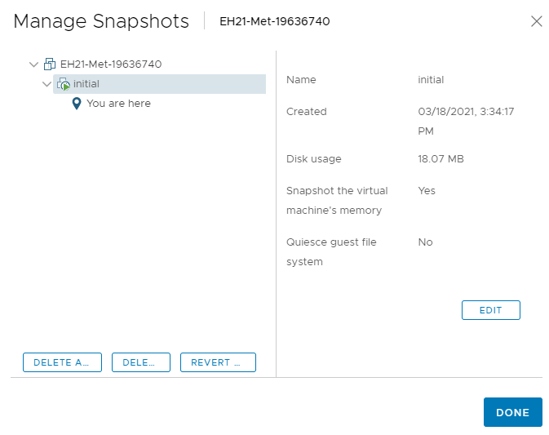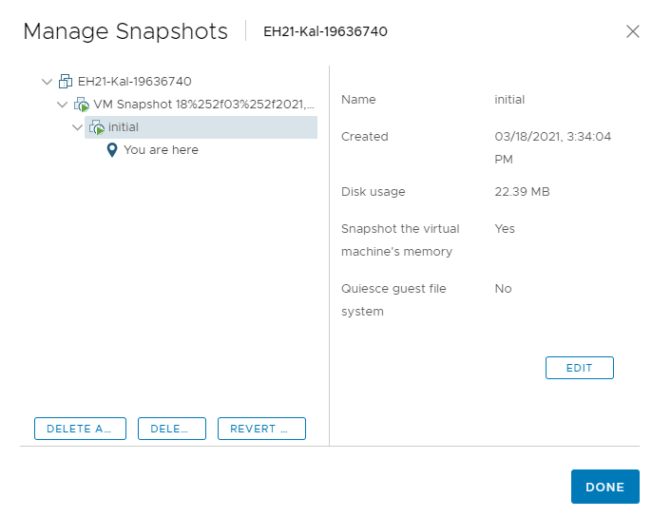
  2. 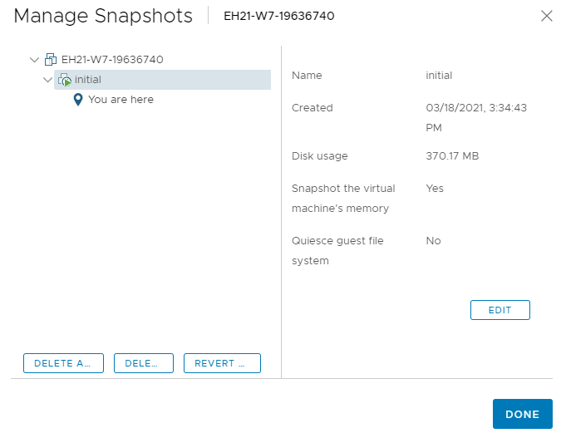

Question 2

2.1 192.168.1.101

2.2 /all

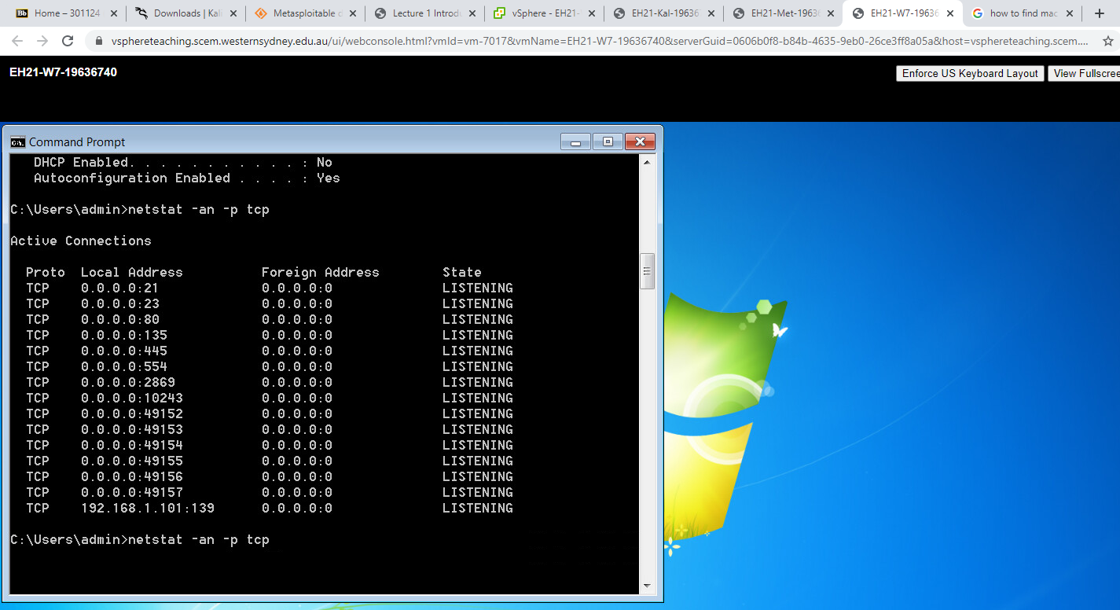 2.3

2.4 -a: display all connections and listening ports.

-n: displays addresses and port numbers in numerical forms

Question 3

3.1 MAC Address: 00:50:56:94:21:2f

Ip address: 192.168.1.103

3.2 Ports: 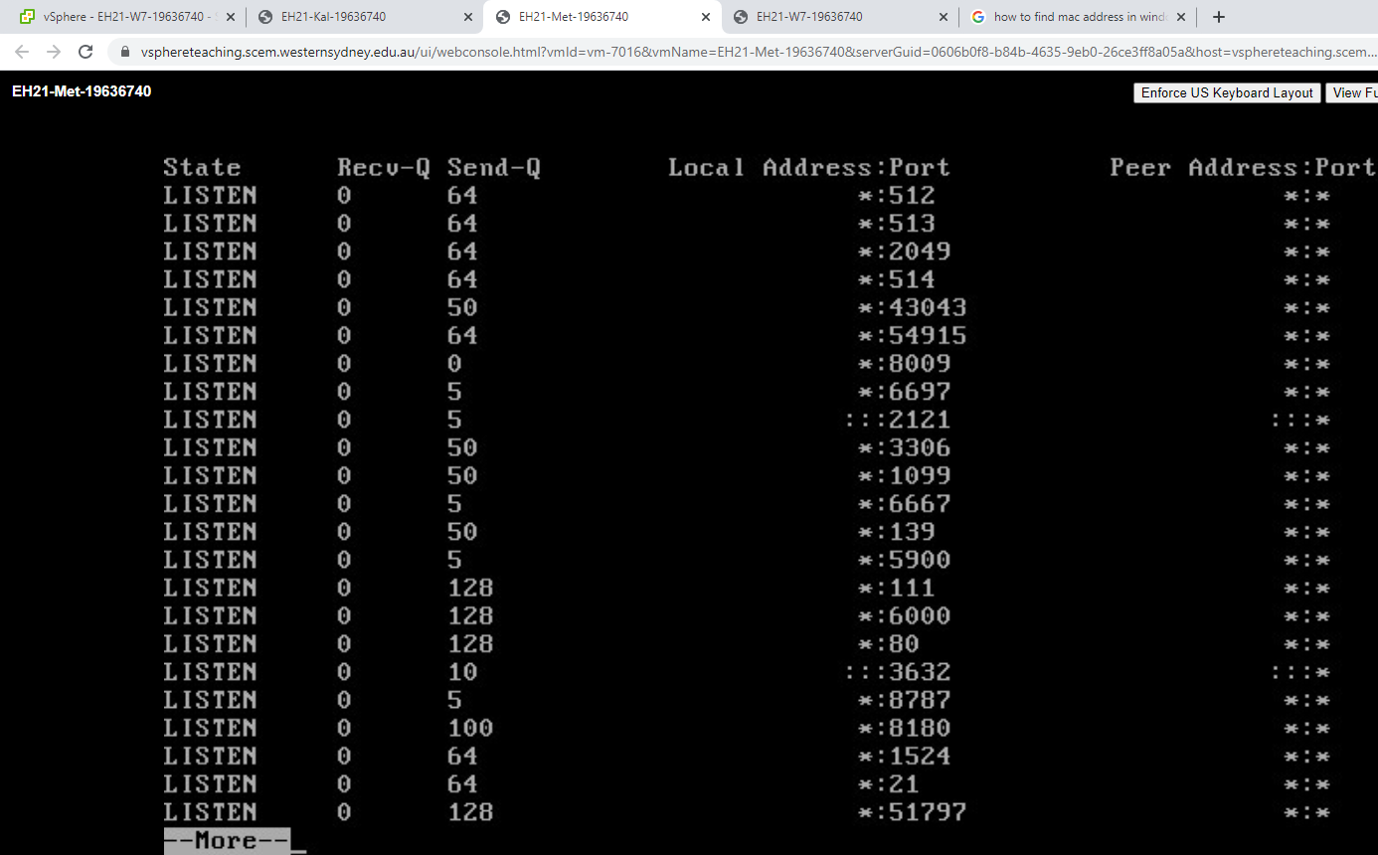

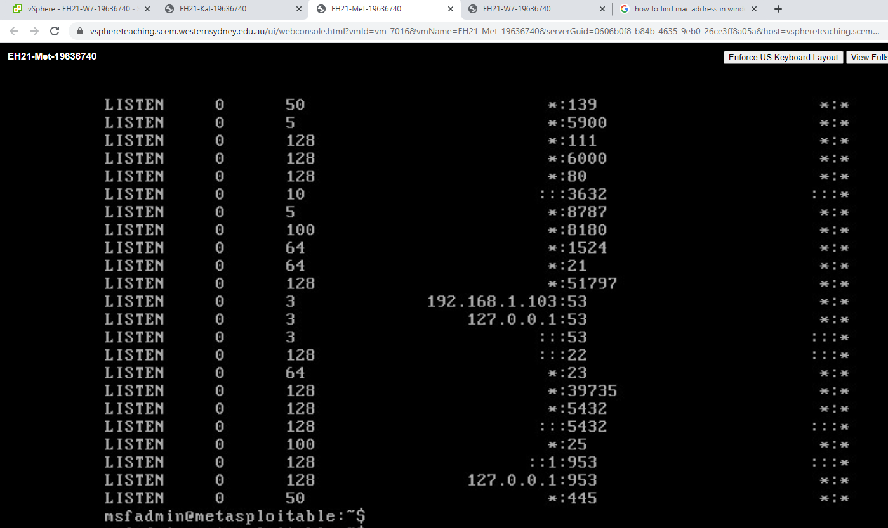

Question 4

4.1 MAC Address: 00:50:56:94:6d:db

Ip address: 192.168.1.102

4.2 no ports.

4.3 <https://www.kali.org/docs/policy/kali-linux-network-service-policies/>

4.4 default gateway: 192.168.1.1

4.5 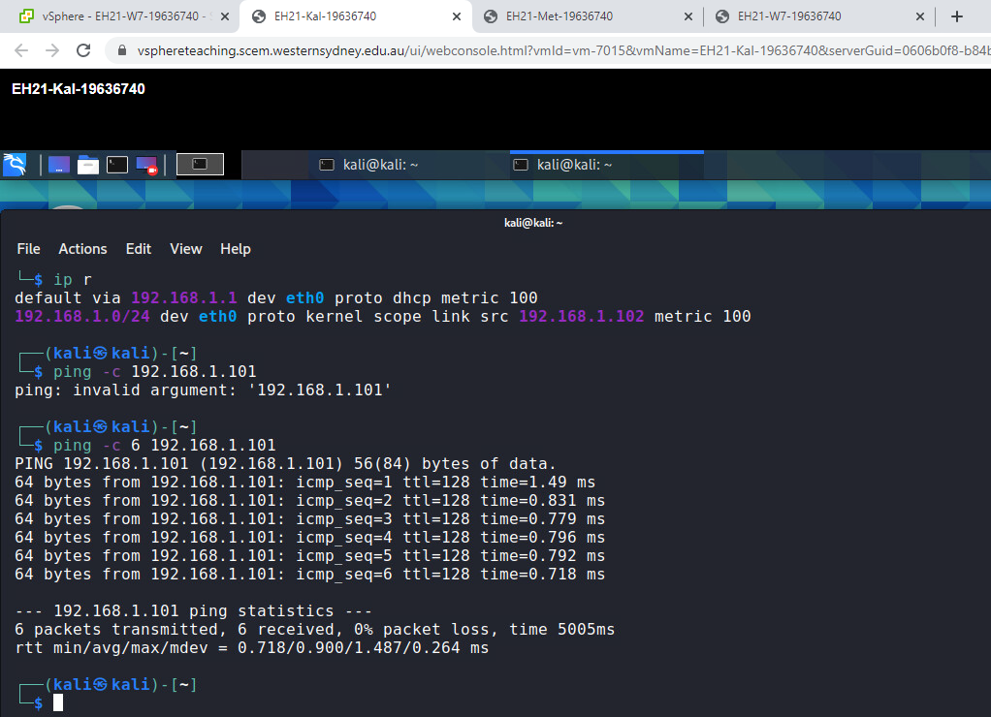

4.6 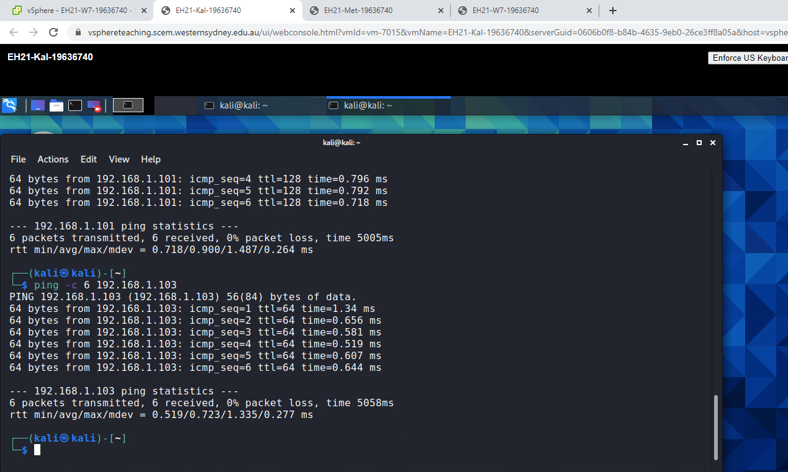

Question 5

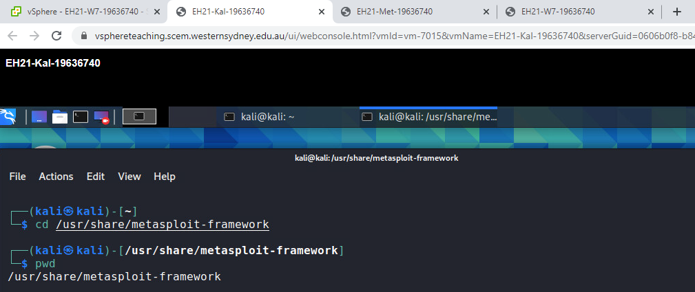 5.1

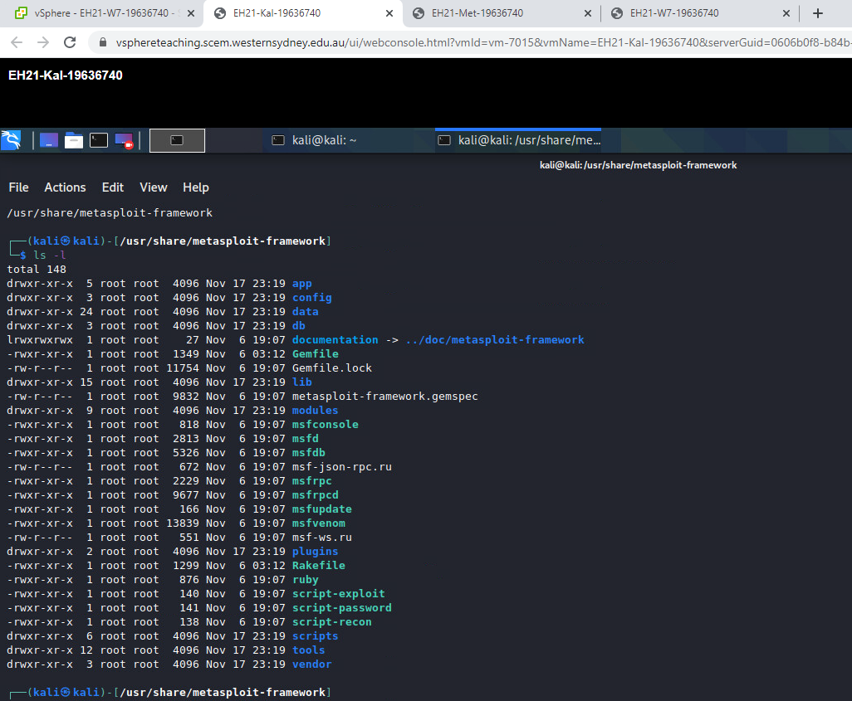

5.2

'cd /usr/share/metasploit-framework': cd is used to set the working directory to the given input, which is /usr/share/metasploit-framework here.

'pwd': print name of current/working directory.

'ls –l ': ls list directory contents, -l is to use a long listing format.

Question 6

6.1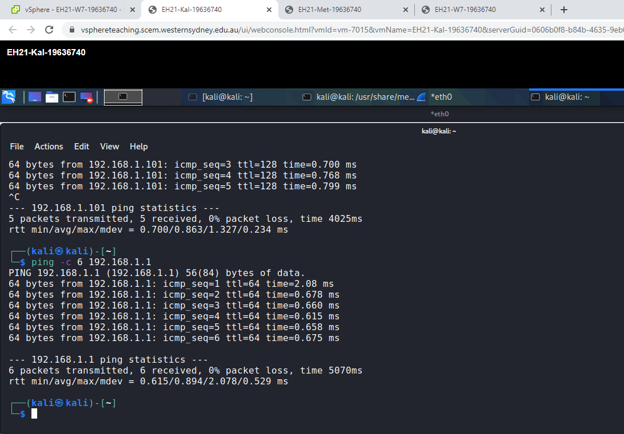

6.2

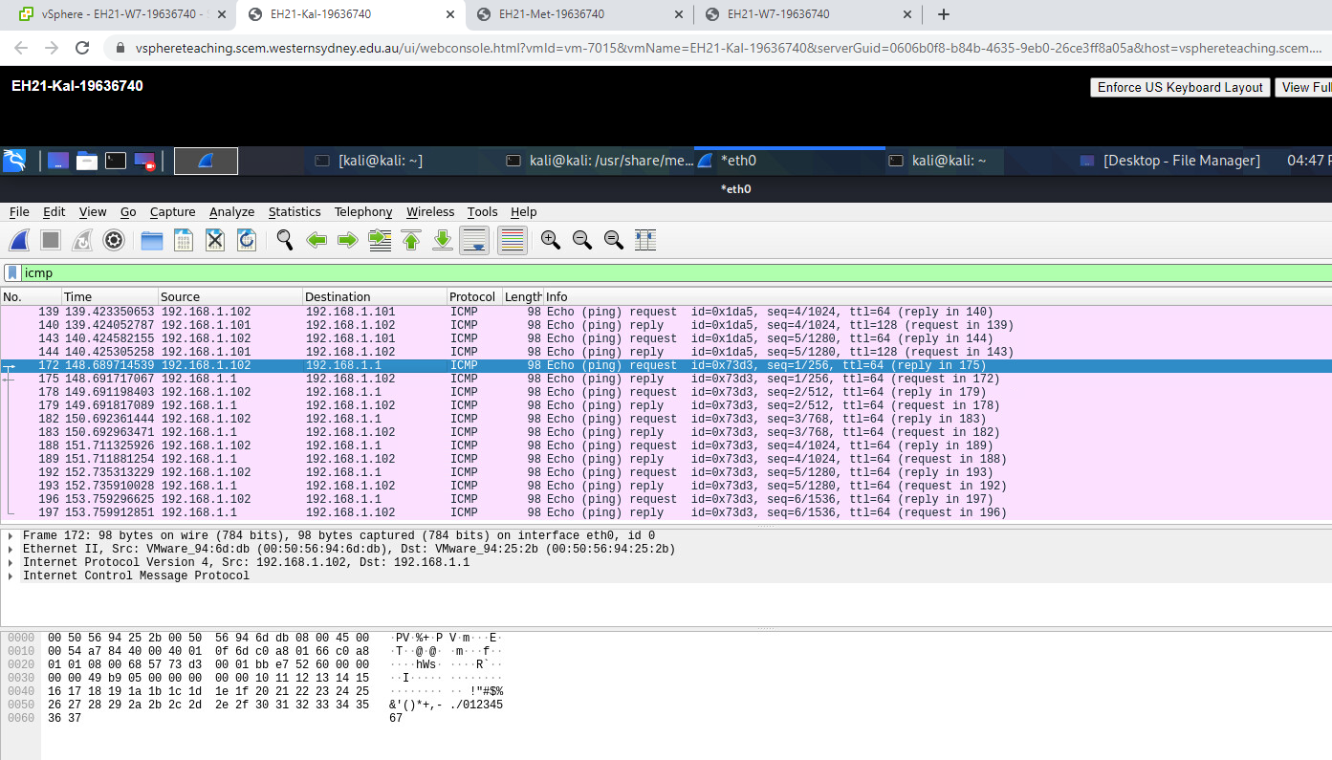

Question 7

7.1

Love is like quicksilver in the hand. Leave the fingers open and it stays. Clutch it, and it darts away.

7.2

A Words with two to three characters are very easy to guess

B For other words that have more than three characters, I used moreword website.